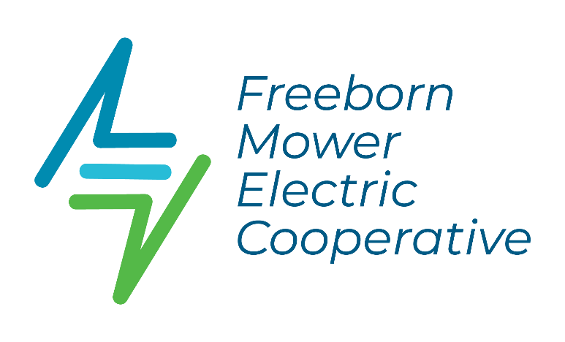
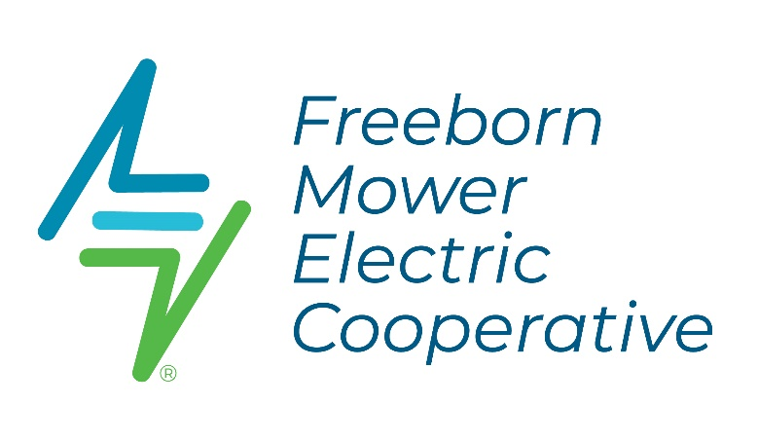
CLASSIFIED MARKETPLACE
Ad Form

Classified Marketplace ads are a FREE courtesy for current FMEC members and are printed in our monthly County Lines Newsletter.
The deadline for submitting an ad is the 15th of the month before the newsletter is published. Ads submitted after the 15th will not be included in next month's newsletter; they will be published in the following month's edition. For example, an ad received on June 16th will appear in August's newsletter. A Classified Marketplace section appears in each newsletter except our Special Annual Report, which typically prints in March.
RULES:
- FMEC members are allowed ONE ad (1 item) per month.
- Requests are first-come, first-served and printed as room allows.
- For Accuracy, we will not take ads over the phone. All ads must be in writing, submitted by the member, and be 15 words or less.
- Preference given to members who have not placed recent ads - we will not repeat ads.
- Ads will not be accepted for real estate, weapons, rentals, storage, land for sale or rent, personal ads, job listings, food products, businesses (to include home-based businesses), notice of meetings, etc.
- FMEC reserves the right to refuse or edit an ad if needed.
SELECT ONE: □ For Sale □ Wanted □ Free/Giveaway
SELECT ONE: □ Animals □ Miscellaneous □ Motorized | Vehicles □ Household □ Farm

AD INFORMATION: (Please print)
_________________________________________________________________________________________
__________________________________________________________________________________________
PLEASE INCLUDE:
Your Name ________________________________________FMEC Account # __________________________
Address___________________________________City___________________________Zip_______________
Email Address: ____________________________________________________________________________
Phone # to use in ad: __________________________________
Please return the form to FMEC, PO Box 611, Albert Lea, MN 56007, or leave it in our 24/7 drive-up drop box.
Alternatively, you may email ads to info@fmec.coop or go to our website at www.fmec.coop and click on the Newsletter tab to submit an ad electronically.

