Classified marketplace
Advertising Guidelines

The Classified Marketplace is a FREE courtesy for current FMEC members.

For accuracy, all ads must be typed or in writing, submitted by the member.

Current members may advertise one item (1) up to 15 words per month. The deadline for the ad is the 15th of the month prior, and it will be published in the following month’s newsletter*.

Ads will NOT be accepted for real estate listings, weapons, rentals, storage, personal ads, job listings, food products, business in general (to include home-based businesses), notices of meetings, or land for sale and rent.

FMEC reserves the right to refuse or edit an ad if need be.

Requests are first come, first served, and printed as the room allows. Preference is given to members who have not placed recent ads – we will not repeat ads.

When filling out your ad, please include your name, address, phone number, and account number.

Submit Ad:

- Return to FMEC, Attn: County Lines Newsletter, PO Box 611, Albert Lea MN 56007, or,
- Leave in our 24/7 drive-up drop box or,
- Email to: info@fmec.coop or go to our website: www.fmec.coop and click on the Newsletter tab to submit an ad.

*A Classified Marketplace section appears in each issue except our special Annual Report issue – typically the month of March.
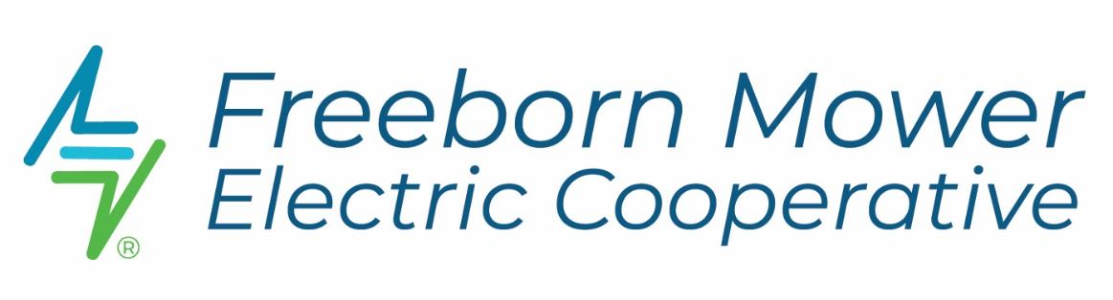
REV 3/07/25

