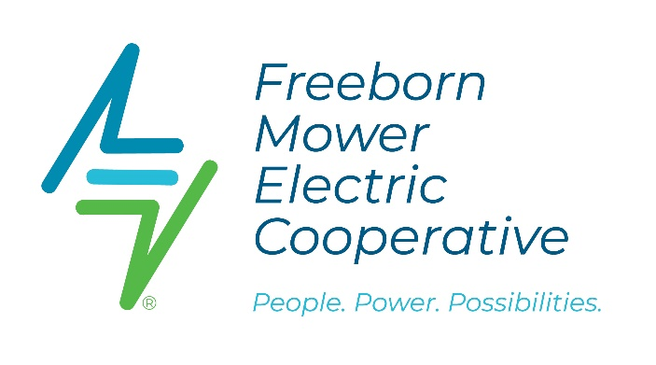
FMEC 1946 Chevy Truck Converted to Electric!

What do a 1946 Chevy truck and an electric vehicle have in common? Nothing. Or so we thought. In partnership with Riverland Community College (RCC), Freeborn Mower Electric Cooperative set out to imagine the impossible and embrace innovation by transforming the oldest truck in the FMEC fleet into an electric-powered vehicle.
Collecting dust in a back corner of the warehouse sat a vintage 1946 Chevy truck that was undrivable. The retired truck was a part of the Rural Electric Association’s fleet dating back to the early 1940s. The “what to do with it” question lingered as it felt like the truck represented a small piece of FMEC history that was too special to scrap or offer to a collector. Now, with the help of an automotive professor (who is passionate about electric vehicles) and six students, the truck is fully operational and has the ability to drive a modest 50 miles on a full charge. It will be a great addition to FMEC’s parade vehicle line-up this summer.
One might think that swapping out an old 80-horse gas engine for an electric-powered one was an easy feat, but not so much. The modifications necessary to adapt the truck to new modern engine components posed opportunities for the students to solve problems, think critically, and work as a team.
The students worked together on the vehicle for over nine months as Professor Olle gave the students guidance and direction. “Essentially, we had to start from scratch by removing the old engine,” he said. Professor Olle Gladso described it as the “most rewarding, challenging, and at times infuriating” process he has experienced in his teaching career.
However, the reward for the students' hard work and persistence has finally paid off, with the inaugural test drive successfully happening on the last day of school. “The students were thrilled, and it gave them a tremendous sense of accomplishment,” said Professor Gladso.
Freeborn Mower Electric Cooperative was proud to partner with RCC on such an exciting project and looks forward to showcasing the transformed truck at upcoming parades and events around our communities this summer.

